Q1:
Full Stack Development refers to the process of building both the front-end (client-side) and back-end (server-side) parts of a web application. A full stack developer is skilled in multiple technologies like html,css, javascript. They handle the complete development process—from designing interfaces to managing data and server logic. Their versatility helps organizations save time and resources by managing both client and server operations and are highly valued and in demand in the tech industry.
Q2:
Front end handles the user interface, the page they interact with, focusing on the visual design and the user experience. THe back-end side handles the sever side, the behind the scene logic of user’s interactions with the page, databases, and server management.

Q3:
HTML : It is the standard language for creating the structure of the webpage. It creates the layout, and content displayed on the webpage such as headings, paragraphs, lists, images, and links. Each element is enclosed within tags that give meaning to the content. Without HTML, a webpage would have no structure or readable content.

CSS : CSS controls the appearance and design of HTML elements on a webpage allowing developers to apply colors, fonts, spacing, and layout formatting easily and seamlessly. By separating style from structure, CSS ensures consistency and flexibility in web design.

JavaScript: JavaScript is a programming language used to make webpages interactive and dynamic. Designs the logic behind the scenes of every interaction between the user and webpage. It enables features like form validation, animations, and responsive behavior to user actions.

Part B:
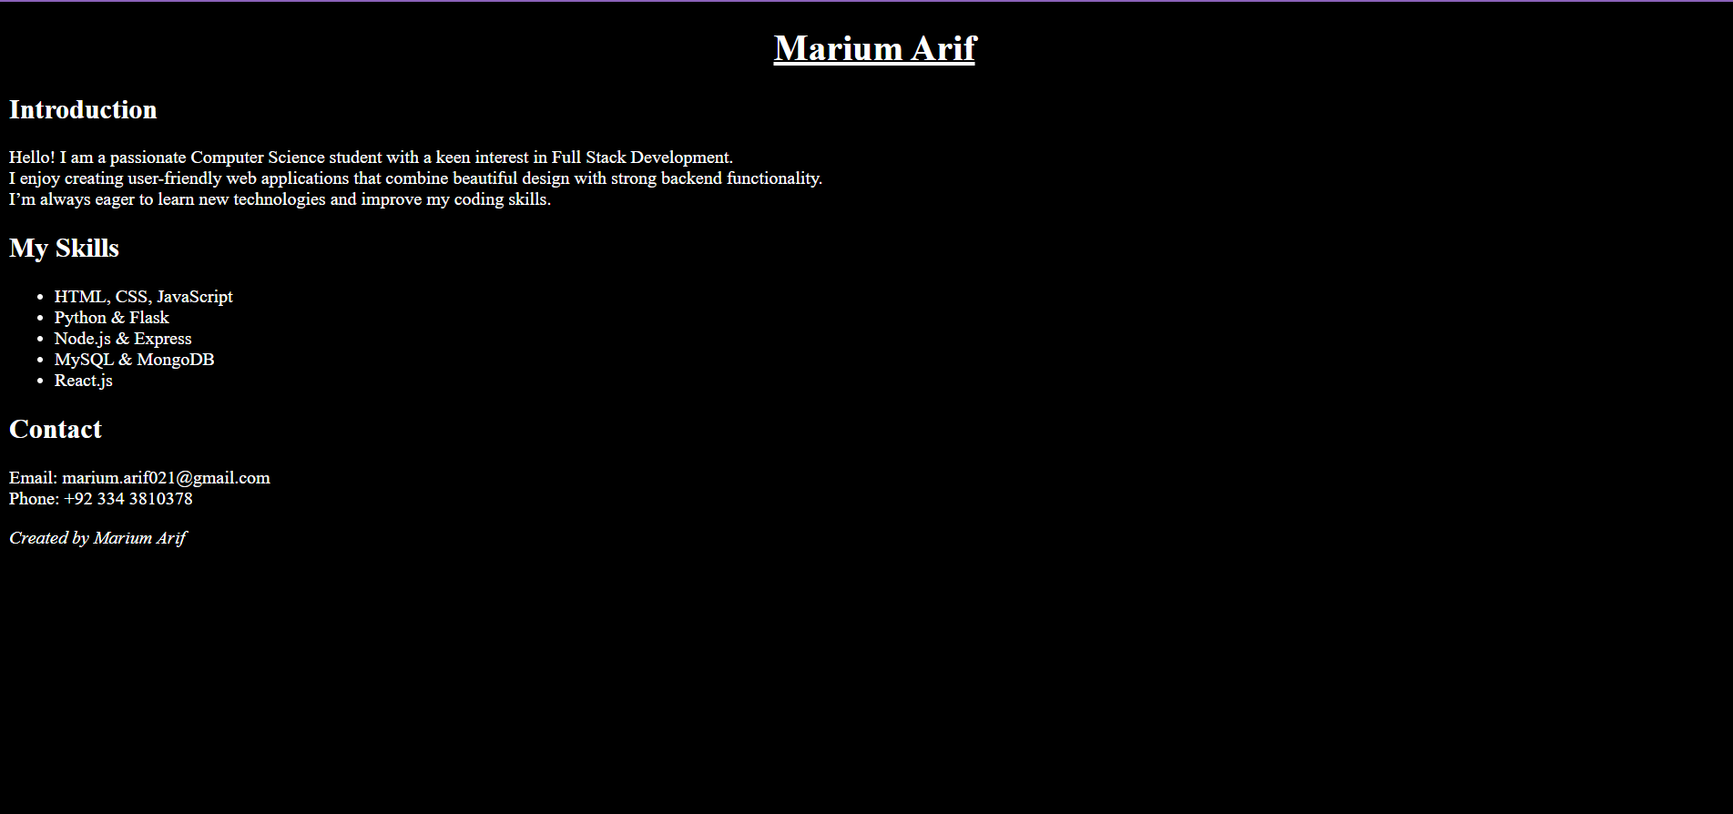
Questions to Answer:
What title did you use for your webpage?
TASK1-basic webpage

What HTML tags did you use and why?
<html>: Defines the root of the webpage.
<head>: Contains metadata and the title.
<title>: Displays the webpage title on the browser tab.
<body>: Contains all visible webpage content.
<h1>, <h2>: Used for main and sub-headings to organize content.
<p>: Displays text paragraphs.
<br> line break
<i> turns text italic
<ul> and <li>: Create an unordered list of skills.
<footer>: Marks the bottom section with creator credit.

How does this webpage demonstrate your front-end knowledge?

This webpage demonstrates my front-end skills by applying HTML structure, semantic tags, and proper content organization. It shows an understanding of how to build readable, accessible, and well-formatted webpages.

